

CIS C290

M06 Lab Assignment: Unsupervised Learning

Activity 1 Part 1. Load the Customers.csv file into the Python environment and recode gender and include a screenshot of the output.
#Read in /content/Mall_Customers.csv
import pandas as pd

df = pd.read_csv('/content/Mall_Customers.csv')
print(df.head())

# Check the actual column names in the DataFrame
print(df.columns)

# Recode gender
df['gender'] = df['gender'].replace({'Female': 1, 'Male': 2})

print(df.head())

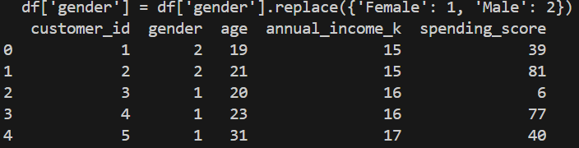

Activity 1 Part 2. Conduct k-Means clustering analysis with a chart and include the screenshots of the output

# Run a k-means clustering and include a chart for gender and spending_score

import pandas as pd
import matplotlib.pyplot as plt
from sklearn.cluster import KMeans

# Print the actual column names to verify
print(df.columns)

# Access the columns using their actual names (e.g., annual_income_k', 'spending_score')
X = df[['annual_income_k', 'spending_score']]

# Determine optimal number of clusters using Elbow method
wcss = [ ]
for i in range(1, 11):
kmeans = KMeans(n_clusters=i, init='k-means++', random_state=42)
kmeans.fit(X)
wcss.append(kmeans.inertia_)
plt.plot(range(1, 11), wcss)
plt.title('Elbow Method')
plt.xlabel('Number of clusters')
plt.ylabel('WCSS')
plt.show()

# Apply k-means clustering with the chosen number of clusters (e.g., 5)
kmeans = KMeans(n_clusters=5, init='k-means++', random_state=42)
y_kmeans = kmeans.fit_predict(X)

# Add cluster labels to the dataframe
df['Cluster'] = y_kmeans

# Visualize the clusters
plt.scatter(X.iloc[y_kmeans == 0, 0], X.iloc[y_kmeans == 0, 1], s=50, c='red', label='Cluster 1')
plt.scatter(X.iloc[y_kmeans == 1, 0], X.iloc[y_kmeans == 1, 1], s=50, c='blue', label='Cluster 2')
plt.scatter(X.iloc[y_kmeans == 2, 0], X.iloc[y_kmeans == 2, 1], s=50, c='green', label='Cluster 3')
plt.scatter(X.iloc[y_kmeans == 3, 0], X.iloc[y_kmeans == 3, 1], s=50, c='cyan', label='Cluster 4')
plt.scatter(X.iloc[y_kmeans == 4, 0], X.iloc[y_kmeans == 4, 1], s=50, c='magenta', label='Cluster 5')
plt.scatter(kmeans.cluster_centers_[:, 0], kmeans.cluster_centers_[:, 1], s=100, c='yellow', label='Centroids')
plt.title('Clusters of customers')
plt.xlabel('Annual Income (k$)')
plt.ylabel('Spending Score (1-100)')
plt.legend()
plt.show()

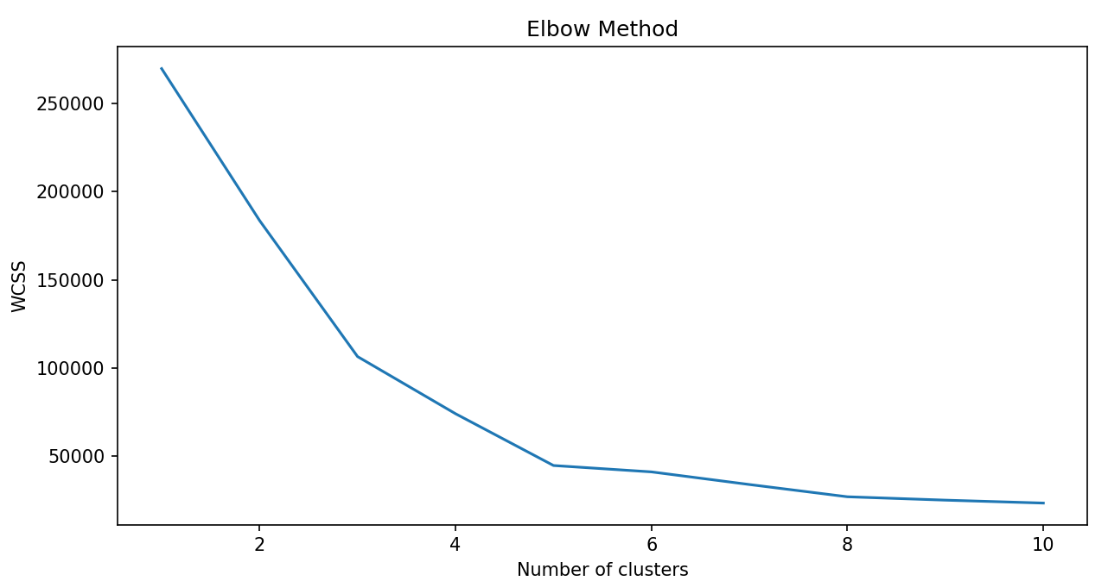
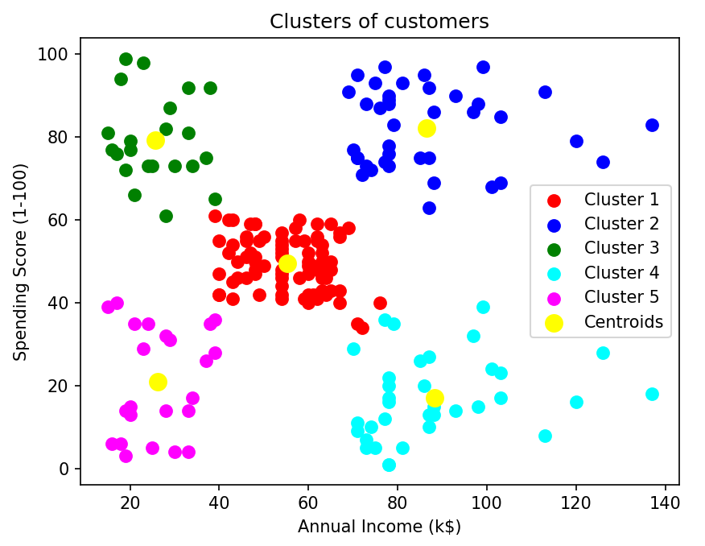

Activity 2. Run Apriori Algorithm or Market Basket Analysis to the Groceries.csv dataset and include a screenshot of the output
import pandas as pd
from mlxtend.frequent_patterns import apriori, association_rules
from mlxtend.preprocessing import TransactionEncoder

# Load dataset
groceries_df = pd.read_csv('/content/Groceries.csv')

# Preprocess and group transactions
transactions = groceries_df.groupby(['Member_number', 'Date'])['itemDescription'].apply(list).tolist()

# Encode transactions
te = TransactionEncoder()
transactions_encoded = pd.DataFrame(te.fit(transactions).transform(transactions), columns=te.columns_)

# Check item frequency to identify suitable support threshold
item_counts = pd.Series([item for sublist in transactions for item in sublist]).value_counts()
print(item_counts.head(15))

# Adjust min_support based on the item frequency (set it lower, e.g., 0.005)
frequent_itemsets = apriori(transactions_encoded, min_support=0.005, use_colnames=True)

# Generate association rules
rules = association_rules(frequent_itemsets, metric="lift", min_threshold=1)

# Sort and display top 10 rules by lift
rules_sorted = rules.sort_values(by='lift', ascending=False).head(10)
print(rules_sorted)

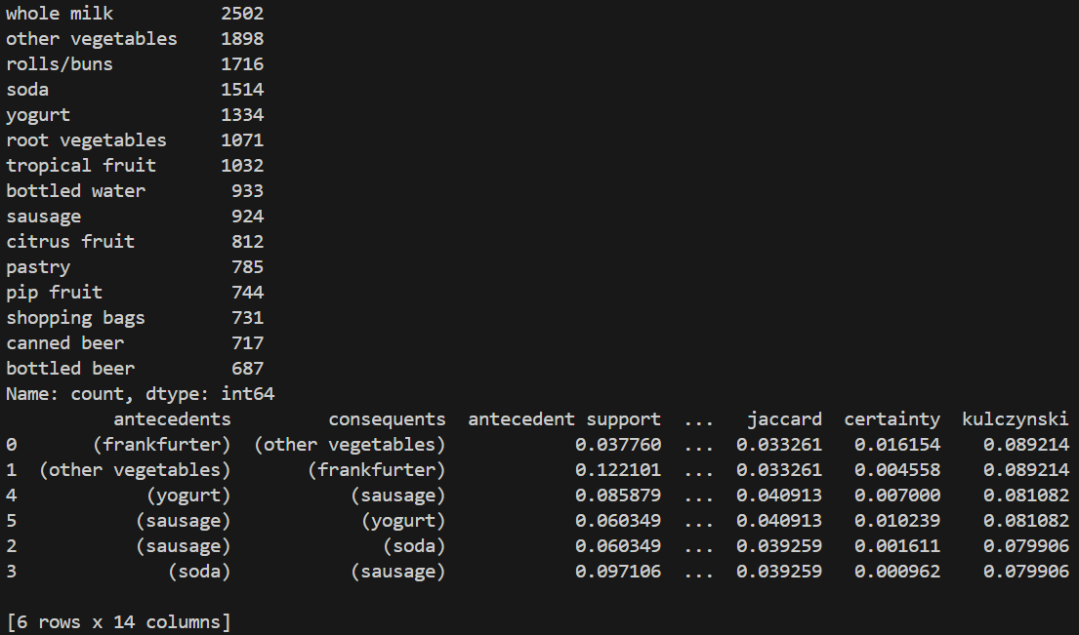

Activity 3. FOR PRACTICE Run a Hierarchical Clustering.
# Import required libraries for dataframe and visualization

import numpy as np
import pandas as pd
import matplotlib.pyplot as plt
import seaborn as sns
import datetime as dt

# import required libraries for clustering
import sklearn
from sklearn.preprocessing import StandardScaler
from sklearn.cluster import KMeans
from sklearn.metrics import silhouette_score
from scipy.cluster.hierarchy import linkage
from scipy.cluster.hierarchy import dendrogram
from scipy.cluster.hierarchy import cut_tree

# Read in /content/Online Retail.xlsx

retail = pd.read_excel('/content/Online Retail.xlsx')

# Dropping rows having missing values - Data cleaning process

retail = retail.dropna()
retail.shape

# Changing the datatype of Customer Id as per Business understanding

retail['CustomerID'] = retail['CustomerID'].astype(str)

# We are going to analysis the Customers based on below 3 factors: R (Recency): Number of days since last purchase F (Frequency): Number of transactions M (Monetary): Total amount of transactions (revenue contributed)

# New Attribute : Monetary

retail['Amount'] = retail['Quantity']*retail['UnitPrice']
rfm_m = retail.groupby('CustomerID')['Amount'].sum()
rfm_m = rfm_m.reset_index()
rfm_m.head()

# New Attribute : Frequency

rfm_f = retail.groupby('CustomerID')['InvoiceNo'].count()
rfm_f = rfm_f.reset_index()
rfm_f.columns = ['CustomerID', 'Frequency']
rfm_f.head()

# Merge the two dfs

rfm = pd.merge(rfm_m, rfm_f, on='CustomerID', how='inner')
rfm.head()

# New Attribute : Recency
# Convert to datetime to proper datatype

retail['InvoiceDate'] = pd.to_datetime(retail['InvoiceDate'],format='%d-%m-%Y %H:%M')

# Compute the maximum date to know the last transaction date

max_date = max(retail['InvoiceDate'])
max_date

# Compute the difference between max date and transaction date

retail['Diff'] = max_date - retail['InvoiceDate']
retail.head()

# Compute last transaction date to get the recency of customers

rfm_p = retail.groupby('CustomerID')['Diff'].min()
rfm_p = rfm_p.reset_index()
rfm_p.head()

# Extract number of days only

rfm_p['Diff'] = rfm_p['Diff'].dt.days
rfm_p.head()

# Merge tha dataframes to get the final RFM dataframe

rfm = pd.merge(rfm, rfm_p, on='CustomerID', how='inner')
rfm.columns = ['CustomerID', 'Amount', 'Frequency', 'Recency']
rfm.head()

# Remove (statistical) outliers for Amount
Q1 = rfm.Amount.quantile(0.05)
Q3 = rfm.Amount.quantile(0.95)
IQR = Q3 - Q1
rfm = rfm[(rfm.Amount >= Q1 - 1.5*IQR) & (rfm.Amount <= Q3 + 1.5*IQR)]

# Remove (statistical) outliers for Recency

Q1 = rfm.Recency.quantile(0.05)
Q3 = rfm.Recency.quantile(0.95)
IQR = Q3 - Q1
rfm = rfm[(rfm.Recency >= Q1 - 1.5*IQR) & (rfm.Recency <= Q3 + 1.5*IQR)]

# Remove (statistical) outliers for Frequency

Q1 = rfm.Frequency.quantile(0.05)
Q3 = rfm.Frequency.quantile(0.95)
IQR = Q3 - Q1
rfm = rfm[(rfm.Frequency >= Q1 - 1.5*IQR) & (rfm.Frequency <= Q3 + 1.5*IQR)]

# Rescale the attributes

rfm_df = rfm[['Amount', 'Frequency', 'Recency']]

# Instantiate
scaler = StandardScaler()

# fit_transform
rfm_df_scaled = scaler.fit_transform(rfm_df)
rfm_df_scaled.shape

rfm_df_scaled = pd.DataFrame(rfm_df_scaled)
rfm_df_scaled.columns = ['Amount', 'Frequency', 'Recency']
rfm_df_scaled.head()

# Hierarchical clustering single linkage:

mergings = linkage(rfm_df_scaled, method="single", metric='euclidean')
dendrogram(mergings)
plt.show()

# Complete linkage

mergings = linkage(rfm_df_scaled, method="complete", metric='euclidean')
dendrogram(mergings)
plt.show()

# Average linkage

mergings = linkage(rfm_df_scaled, method="average", metric='euclidean')
dendrogram(mergings)
plt.show()

# 3 clusters

cluster_labels = cut_tree(mergings, n_clusters=3).reshape(-1, )
cluster_labels

# Assign cluster labels

rfm['Cluster_Labels'] = cluster_labels
rfm.head()

# Plot Cluster Id vs Amount

sns.boxplot(x='Cluster_Labels', y='Amount', data=rfm)

# Plot Cluster Id vs Frequency

sns.boxplot(x='Cluster_Labels', y='Frequency', data=rfm)

# Plot Cluster Id vs Recency

sns.boxplot(x='Cluster_Labels', y='Recency', data=rfm)

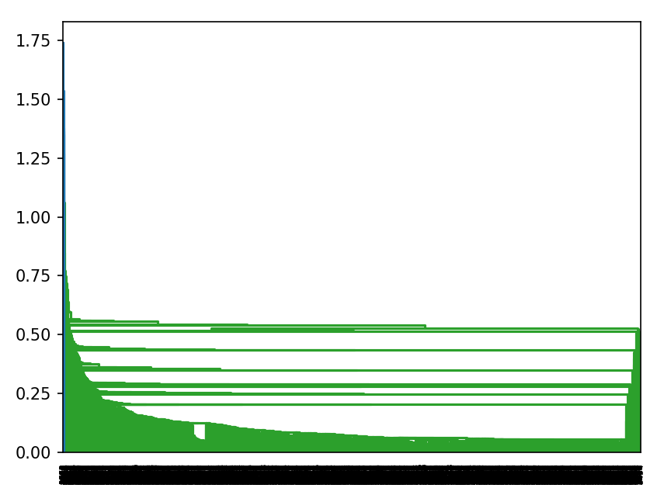
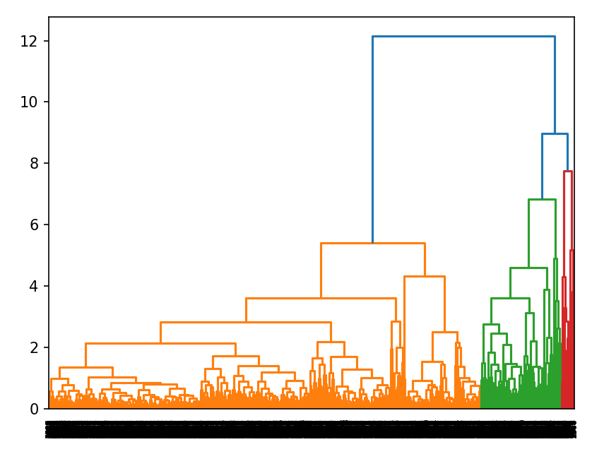
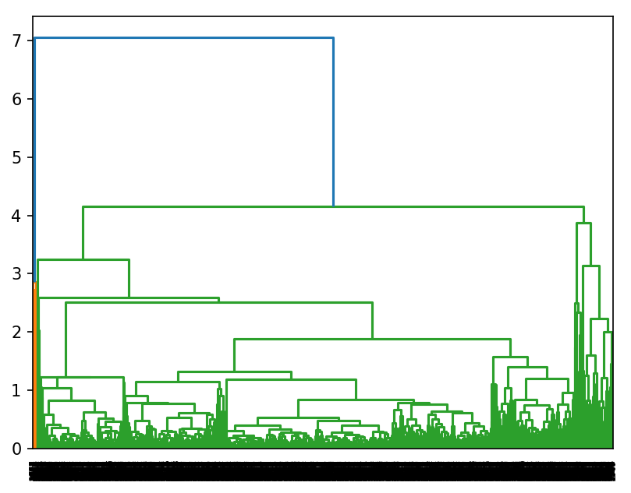
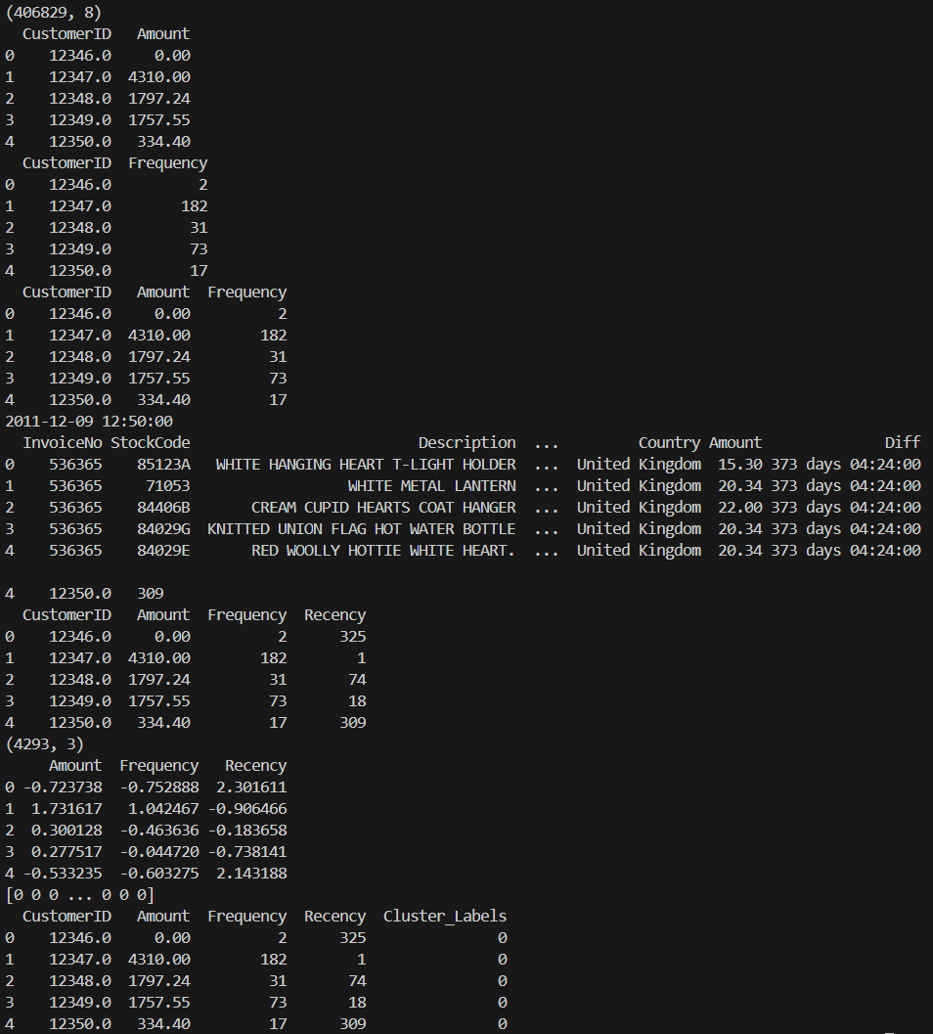

Activity 4. In a minimum of 3 sentences, describe your experience with the assignment. Indicate which resources you used.

Throughout the lab, I had some trouble with the new file extension (xlsx) as it was not allowing read in my IDE. I managed to fix it by installing another module. Also I had issues with my new pc not having the right dependencies, which were all solved through dependency installment. Overall not too much issues during the lab.

